** PAS**

**To:** Dr. Matt Bohm

**From:** PAS

**Project:** Plasma Arc Speaker

**Subject:** Concept Variant 4

**Date:** March 4, 2011

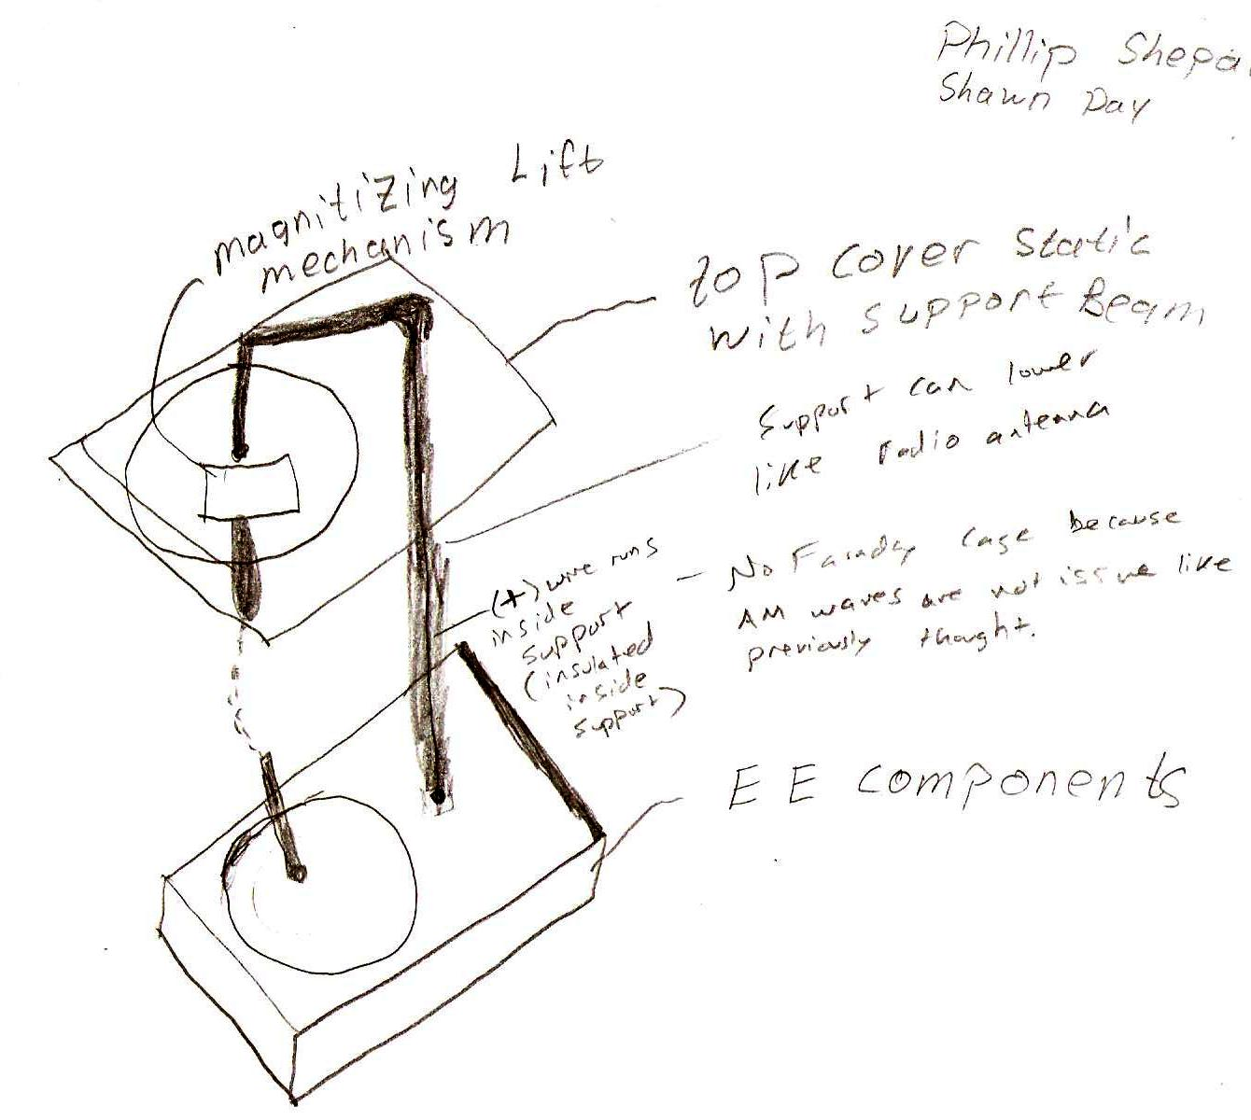

CV 4 has a housing on the bottom for the electrical components with a column that holds the top electrode. The top has a magnetic mechanism that lifts the top electrode as soon as the arc is made.  The top slab has slots to snap the Faraday cage in, if needed.  The column moves up and down like a car antenna to adjust the volume.  The wiring to the top electrode is located inside of the metal column.